5/11/2018 Notes:

Today, we had a meeting to discuss future plans and how we will make things come to be.

Materials we still need:

* Male to male jumper wires
* ESP8266 12E WiFi Shield – to connect our Arduino to WiFi
* Trash bin (with lid)

Things researched:

* How to connect the ESP8266 12E WiFi Shield to the Arduino…

<http://www.instructables.com/id/ESP-12E-ESP8266-With-Arduino-Uno-Getting-Connected/>

* How to connect and use the Servo motor for our trash bin.

<https://www.hackster.io/omer-beden/smart-trash-77be58>

<http://omer.beden.net/akilli-cop-kutusu/>

https://www.arduino.cc/en/Reference/Servo

* Using blynk, updating the values in the application and virtual pins.

<http://docs.blynk.cc/#blynk-main-operations-virtual-pins>

Until we have everything connected, we can only work on the software side of the project. Even so, we cannot test our software until a future meeting once we have our supplies.

What we need to do:

EVERYTHING.

Figure out an incentive system.

5/17/2018 Notes:

Work-a-thon

We got male-to-male jumper wires from supply.

* Red wire – gnd connective
* Pink wire – 3.3v -> VCC
* Green wire – digital 7 -> sig

I uploaded some sample code onto the Arduino IDE and got it running, so now it can take the input from the ultrasonic ranger.

I am also trying to connect the ESP 12E to the breadboard and everything, but I am still at a loss. Dillon recommended that I look up voltage divider, so I will do that soon.

5/21/2018 Notes:

We are going to try to connect the ESP8266 to the breadboard, but we do not know the pinout because it was a spare instead of what we initially ordered.

PINOUT:

<https://components101.com/wireless/esp8266-pinout-configuration-features-datasheet>

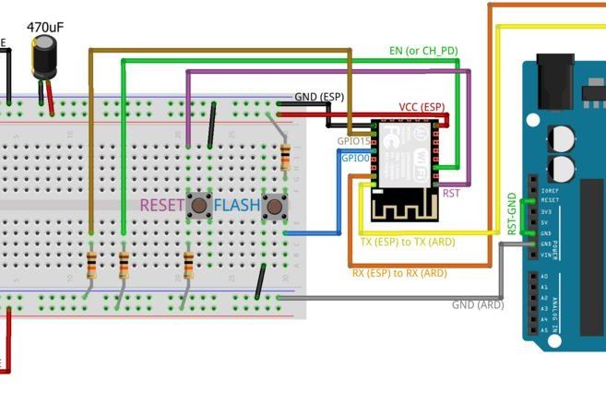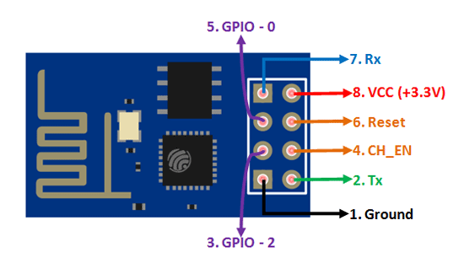

Ground – short wire

GP100 – short wire

VCC – short wire

Rx – long wire

EN – long wire

GPO15 – long wire

RST – long wire

Tx – long wire

Soldering is rough.

Agenda:

We need to find a way to take a user input from Blynk. This will be for the height of the trash can, from which we will calculate the %fullness.

We also need to continue soldering and connect the Arduino UNO to WiFi.

5/26/2018 Notes:

We are going to try connecting the ESP8266-01 Wifi Shield Module to the breadboard to connect to the Arduino instead of soldering it directly.

Today, I started reading the method of preparing the Wifi Shield to go into the breadboard. I have removed the plastic spacers on the pins of the module.

I used this tutorial to learn more about breadboards:

<https://www.sciencebuddies.org/science-fair-projects/references/how-to-use-a-breadboard>

We will be using this circuit diagram:

<http://www.teomaragakis.com/hardware/electronics/how-to-connect-an-esp8266-to-an-arduino-uno/>

We will be using this method to put the Wifi Shield into the breadboard:

<http://www.instructables.com/id/Making-ESP8266-01-module-breadboard-friendly/>

We will be using this tutorial to test the Wifi Shield:

<http://www.instructables.com/id/Cheap-Arduino-WiFi-Shield-With-ESP8266/>

This is the circuit that I have designed that will use the breadboard to connect to the Arduino uno. The small square on the bottom is the grove ultrasonic ranger.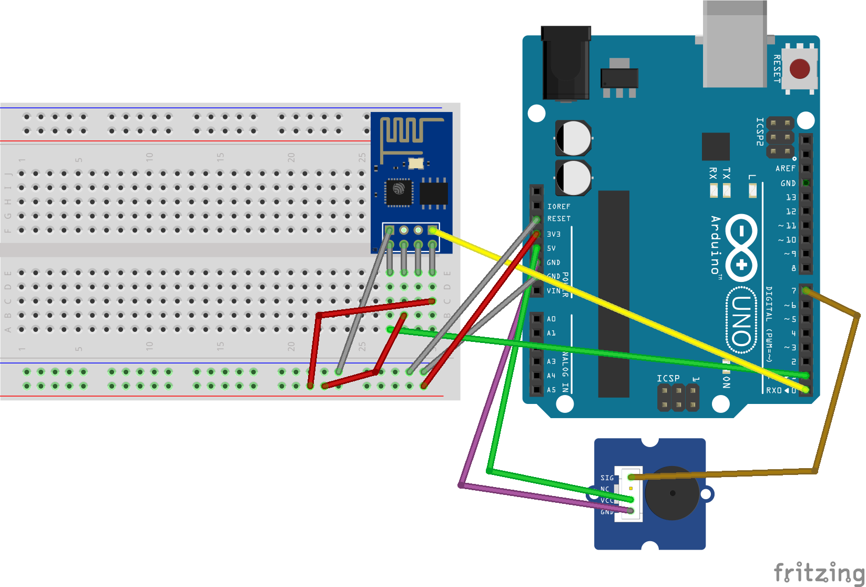

We will try to implement this circuit.

Supplies needed:

Jumper wires

5/29/2018

We were able to get the ESP8266 connected to the breadboard and have the jumper wires connect the breadboard to the Arduino.

We faced difficulty in uploading the sketch and identified that the problem was the reset wire. After reinstalling the IDE and reconnecting the reset wire, we were able to successfully upload the sketch and test the program.

Next issue to resolve: Connecting the Arduino + ESP8266 to wifi and the actual Blynk application.

5/31/2018

Today we tried to fix the connection between the ESP and Blynk to no avail. The assumed issue is the power source, so we will try to provide power to the ESP without using the 3.3v pin from the Arduino.

6/1/2018

To fix our problem…

1st approach: We tried to change the power source of the ESP from the 3.3v to 5v pin on the Arduino.

Success. Using AT+CWMODE to 1

<https://medium.com/@cgrant/using-the-esp8266-wifi-module-with-arduino-uno-publishing-to-thingspeak-99fc77122e82>

<https://www.esp8266.com/viewtopic.php?f=13&t=4246&start=4>

By adding some code into our thing and inserting the AT commands in the setup, we were able to get Blynk to connect for a split second.

Furthermore, I updated our circuit schematic to reflect the changes we made.

The first major change was to switch the 3.3v wire to the 5v wire, however the grove ultrasonic ranger also took advantage of this pin, so I updated the ranger’s wire to connect to the breadboard pin right next to the 5v wire.

The second major change was switching the RX/TX wires connecting from the ESP8266 to pins 10 and 11.

Overall this makes for a neater schematic as it reduced one of the wires necessary, but it does mean that the grove ultrasonic ranger has to be connected to the breadboard directly as well instead of just the Arduino Uno.

